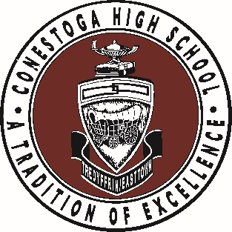
IMPORTANT DATES FOR SENIORS 2024-2025
You can find all of these dates and important links at tesd.net>stoga>especially for seniors

Sep 3: High School Transcript Release/Recommendation Waiver form due (in PowerSchool)
Sep 3: Diploma Information form due (in PowerSchool)
Oct 29 & 30: Last days for senior portraits at CHS (3-8pm)
Oct 31: Deadline for cap and gown orders (CHS website)
Nov 4: Deadline for yearbook senior photo selection, Then & Now pics and Parent “Ads” (CHS website)
Dec 13: Senior parents host Faculty/Retiree Holiday Dessert Reception
Jan 8 & 9: Senior Experience Elective Phase I Presentation during L&L (mandatory)
Jan 10: EEPE verifications forms due for 1st semester (PowerSchool)
Jan 24: Senior Experience Elective Phase I materials due (Schoology)
Feb 5 & 6: Senior Experience Elective Phase II Presentation during L&L (mandatory)
Mar: Graduation and Reflections Speech Tryouts (date tbd)
Mar 26: Senior Experience Elective Phase III meeting during L&L - mandatory for all seniors who have not communicated their SEE plan to Mrs. Braun
Apr: Musical Performers for Reflections selected (date tbd)
Apr 7 – 22: Senior Prom Tickets on sale in PowerSchool (all student debt must be settled prior to purchasing ticket)
Apr 11: All Senior Experience Elective forms due (Schoology)
Apr (mid) : – Record Names for Marching Order
Apr 24: Senior Prom at The Foundry, 8-11pm
Apr 25: Senior EEPE verification forms are due for 2nd semester (PowerSchool)
May 1: Post Graduate plans/Final Grade Request form due (students provided this form by counselors)
May 2: Senior laptop collection, 8-11am at Tech Deck (for those not using laptop for SEE)
May 2: Snow Day in May, 11am-1pm at track
May 5 – May 16: AP Exams
May 5: First Day of Senior Experience Elective
May 16: Senior Experience Elective Midpoint Journal due in Schoology
May 29: Senior Experience Elective Final Journal due in Schoology
May 29: Senior Awards Night, 7pm
May 30: Last day of Senior Experience Elective
May 30: Laptop collection #2 at CHS (10am-12pm)
Jun 2: Final laptop collection at CHS (12pm-2pm)
Jun 2: Senior Reflections at Daylesford Abbey, 7pm
Jun 3: Graduation Rehearsal, 9am, Teamer Field (rain dates 6/4, 6/5) (check student’s debt prior to rehearsal)
Jun 3: Cap and gown distribution (following rehearsal, if all debts are settled)
Jun 3: Yearbook distribution for seniors (following rehearsal)
Jun 3: Graduation, 6pm (rain dates 6/4, 6/5)

- Senior Experience Elective is the new name for the Senior Internship Program.
- Some Senior Activities are promoted by Student Council or the Senior Class and will be promoted via Schoology.
- Student debt includes School Café, textbooks, course fees, and laptops. Debts for textbooks and course fees can be found in PowerSchool. Cafeteria debt can be checked at www.schoolcafe.com. Laptops and chargers must be returned by above dates or student will be assessed $405 and $48 respectively.

